Good morning!! 😊

First of all, create yourself a branch, for this go to the git and update the repository (git pull)

Later create your own branch (git branch name) then push it to the repository (git push origin name) then check if you got it in github, it should be like this 🡪

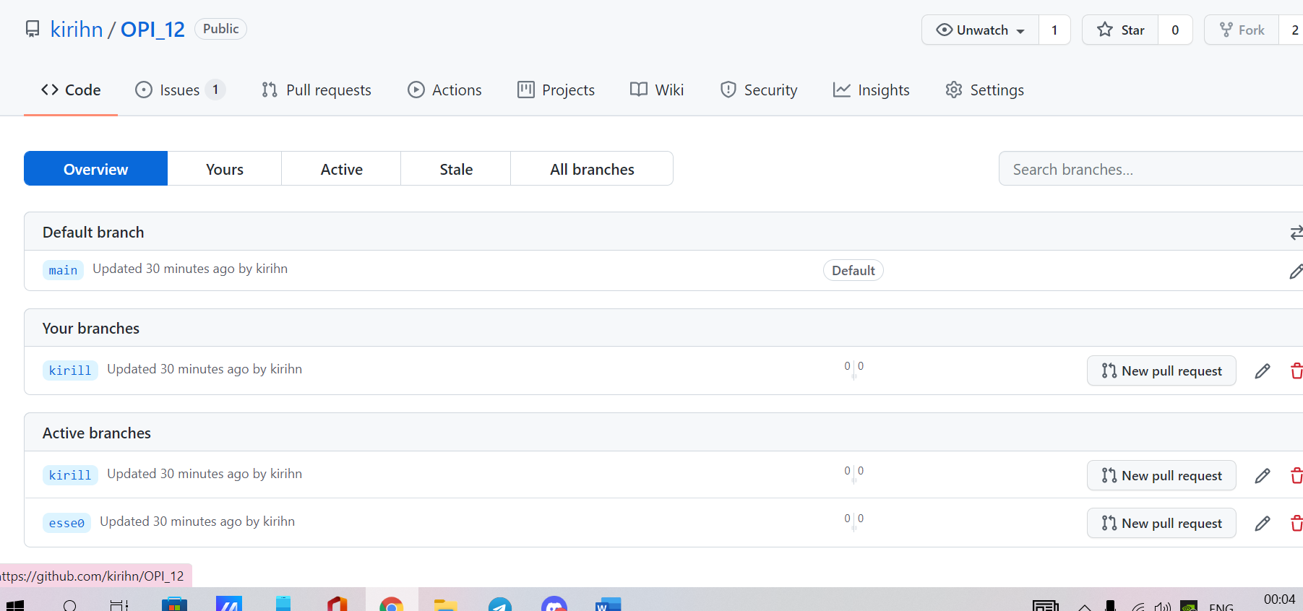

But also with your branch.

Next, you shuld go to your branch (git checkout name) and make all the changes there

I'm waiting for your suggestions on how to implement the project, write them down in your file 🡪 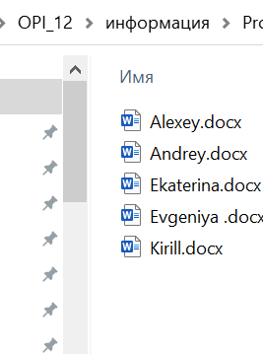

Next, Andrey must create his own folder here 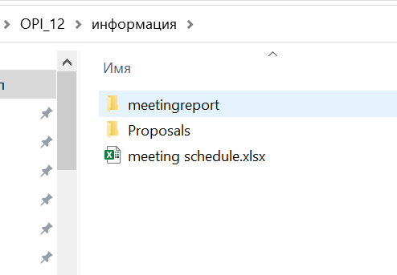

There you should write the requirements for the project (after reading our presentation about the implementation)

Taking these requirements into account, Katya and Zhenya are designing the program separately for the phone and separately for the computer.

Katya or Zhenya (it is important that there is one person) can already start developing the design for the site (its structure, number of pages, team page)